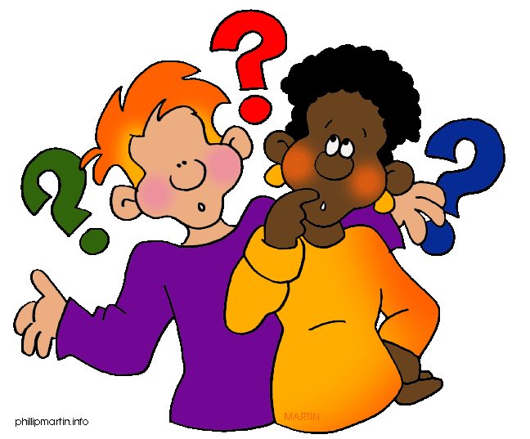
Fusion Lesson 1.2: Scientific Investigations (pages 18-31)
- What is a scientific experiment?

- Complete the chart using the information in your book.
Investigation Type | Benefits | Limitations
Experiments
Observations
Models

- What is the basic requirement of a hypothesis?

- What is the difference in a dependent and independent variable? Be specific.

- How is data used by scientists?

- List the steps of the scientific method.

- How can a hypothesis be tested?

- Why do scientists need to repeat experiments?

- What is the difference in replication and repetition?

- How do you know if scientific results and information are reliable and trustworthy?

- What is the most interesting thing you learned in this section?

