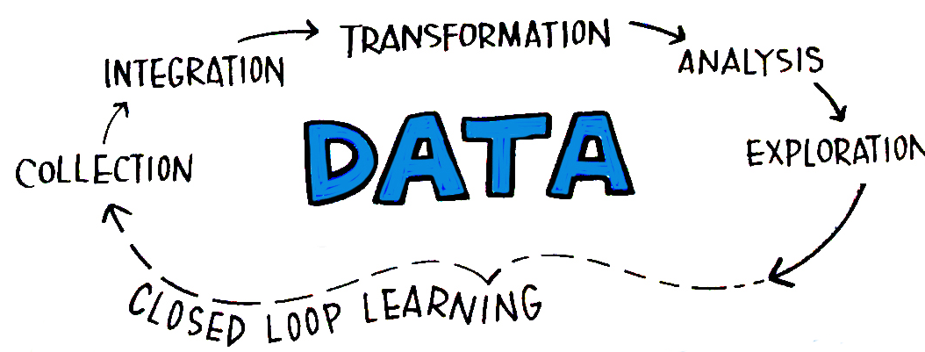
- How do scientists make sense of data?
a.
b.
- Tables
- Tables are used to ________________ and ________________ data
- Data may be measurements or observations
- Tables are organized into _______________ and _______________________.
- Units of measurement in column headings
- Graphs show relationships in data
- Circle graph – __________________________________
- Bar graph – ____________________________________
- Line graph – ____________________________________
- Models
- Models are visual or mathematical representations of an object or system
- Models show things too small, large, complex or dangerous
- Models cannot always show everything they represent
- What principles do scientists use when measuring experimental results?
- Scientists must be very careful when taking measurements
- Data is measured against a ________________________________.
- Precision tells __________________________________________________________.
- Accuracy refers ____________________________________________________________.
